**TestRail Tutorial**



Keep in mind that this is a sample tutorial. Atlassian regularly changes some of the steps for the registration, but we assume that if you are considering exploring the QA profession, you have the basic skills to download and install software without any problems.

**1. Create TestRail Account**

You get a [**free TestRail trial version here**](https://www.gurock.com/testrail).



**Note:** When your trial expires, you can use disposable mail services such as <https://temp-mail.org/en/>, <https://tempmailo.com/>, <https://www.disposablemail.com/> to create a new one.

1. Fill in the required information:

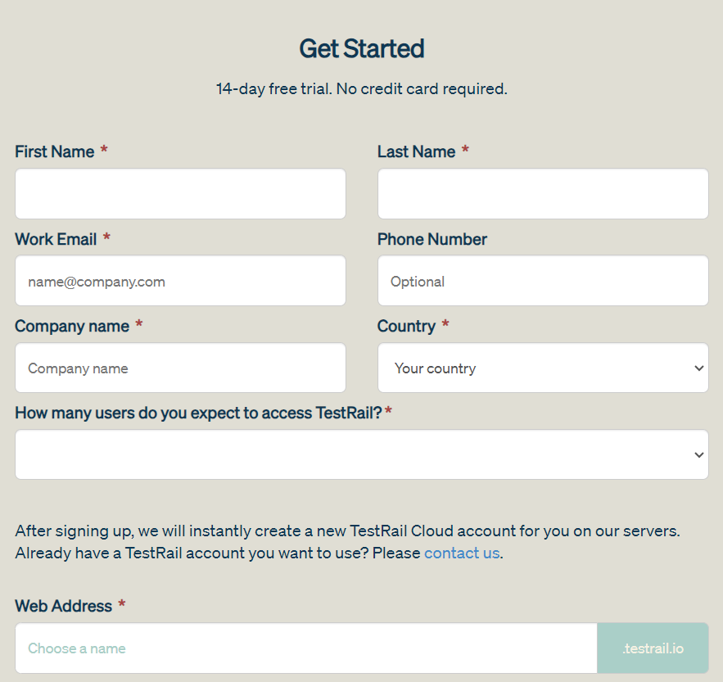

You’ll receive an email with a link to confirm your free trial. Click the link to create your TestRail account.

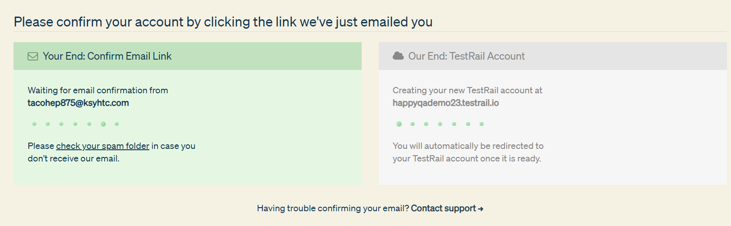

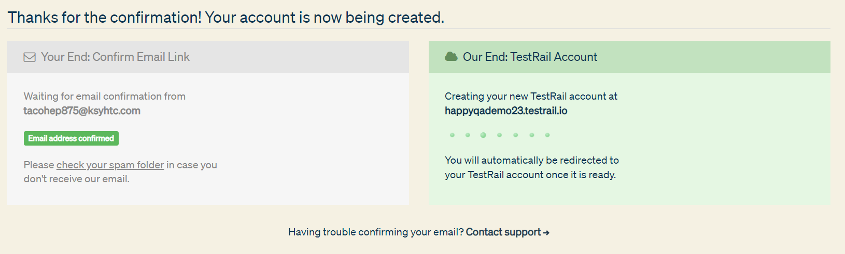

You’ll be automatically redirected to your trial TestRail instance once it is ready. This process should take just a few minutes.

2. There are three questions and it's up to you if you want to answer.

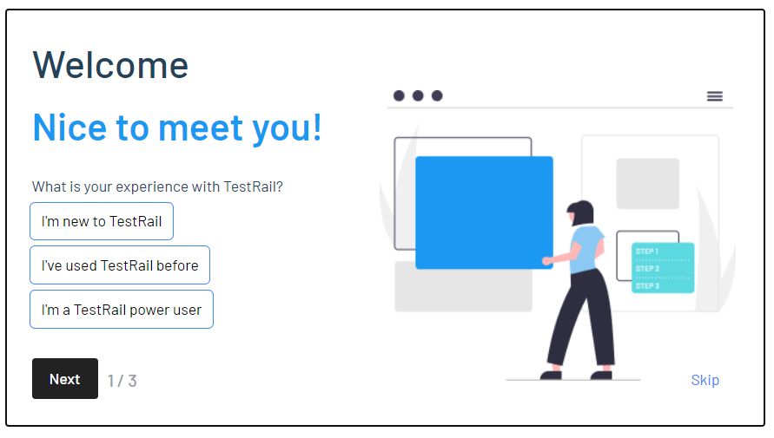

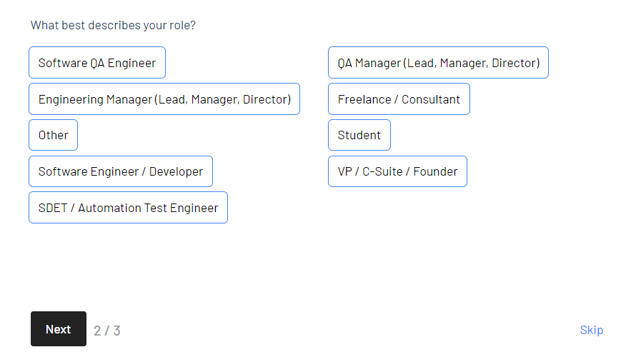

On the third question you might want to choose "Jira", but it is not necessary

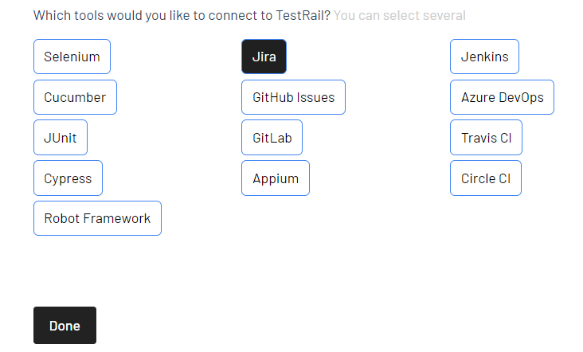

**2. Getting Started**

**2.1.** The screen that you see below is the TestRail **Dashboard**.

The dashboard shows an overview of your projects, recent activities, and any "to-dos" assigned to you.

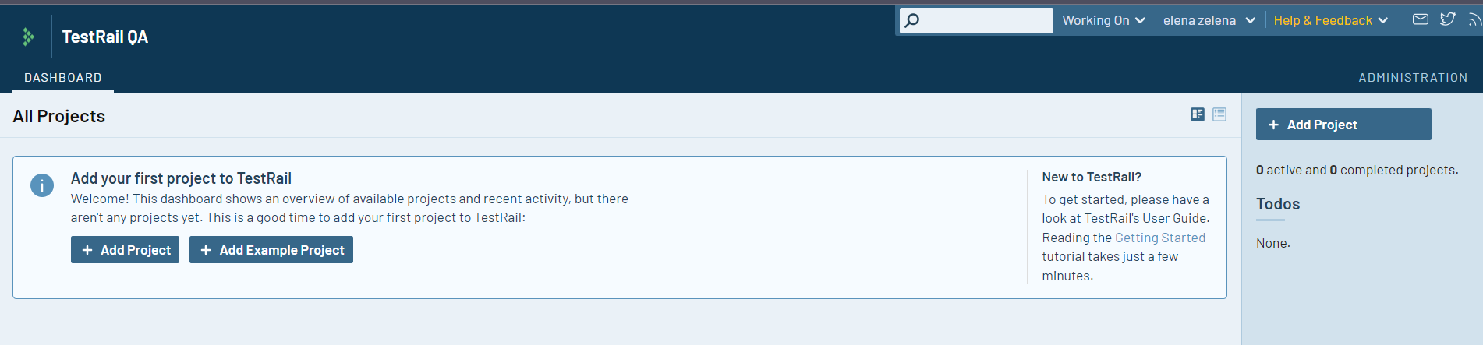

**2.2.**  Click the **Administration** tab. You need to come here to do things like add users and roles, extend your trial subscription, configure custom fields, set up integrations, and more.

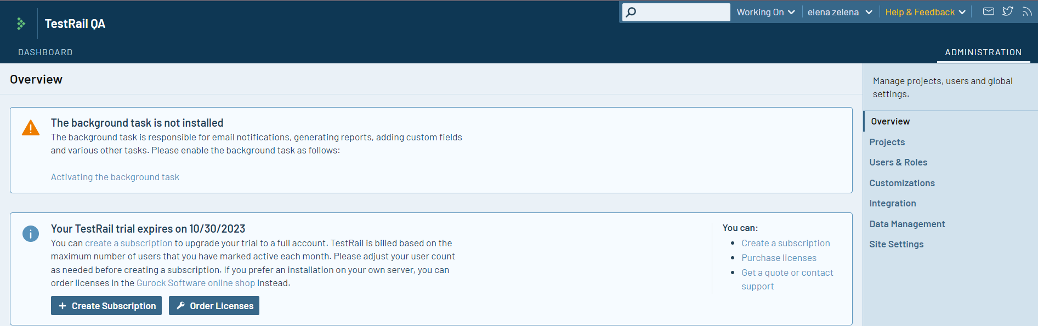

Click on **Users and Roles**, and you'll see that you have been added as the administrator.

Click the **Roles** tab, and you'll see the predefined roles i.e. Read-only, Tester, Designer, and Lead. Click the pencil icon to view the rights assigned to each role. It's easy to change the default descriptions, create additional roles, add one or more users, assign them to roles, organize them into groups, etc.

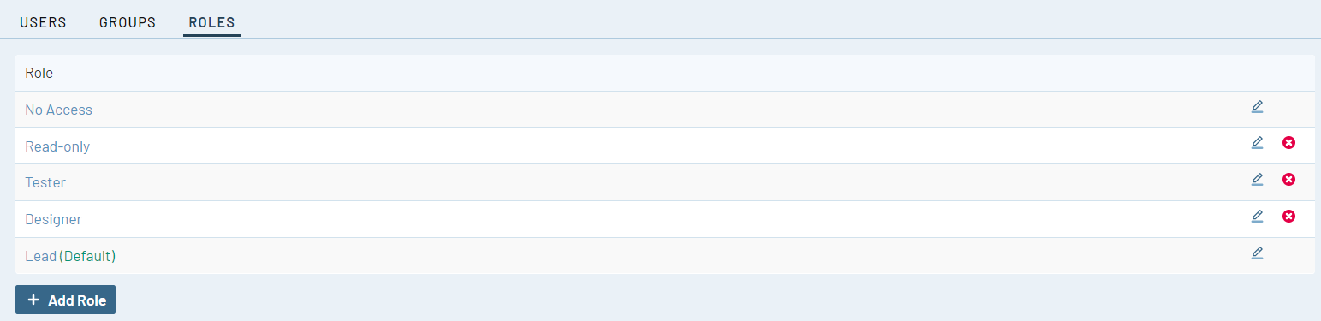

**2.3.** Use the **Dashboard** tab to return to the Dashboard. This is where you'll manage and track your testing projects. Let's start by creating a project. Click the **Add Project** button to do so.

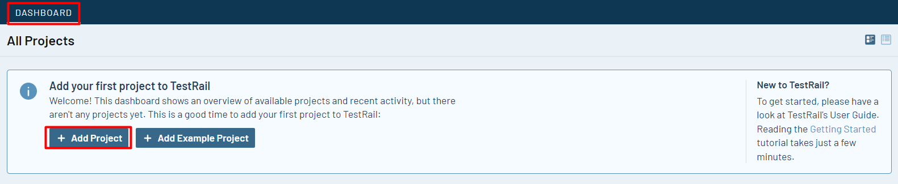

**3. Create a Project**

**3.1.** Give your project a name. For greater flexibility, you should choose the third option: **use multiple test suites to manage cases**.

This allows you to start with a single test suite and then add more test suites in the future if required.

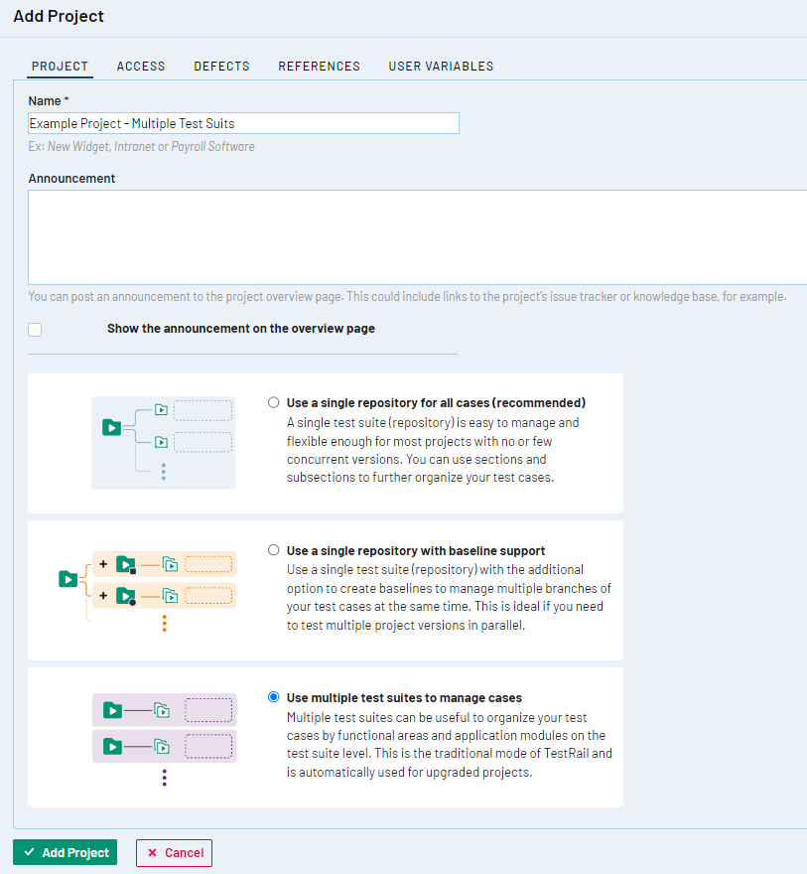

**3.2** Click **Add Project**. You've just created your first project.

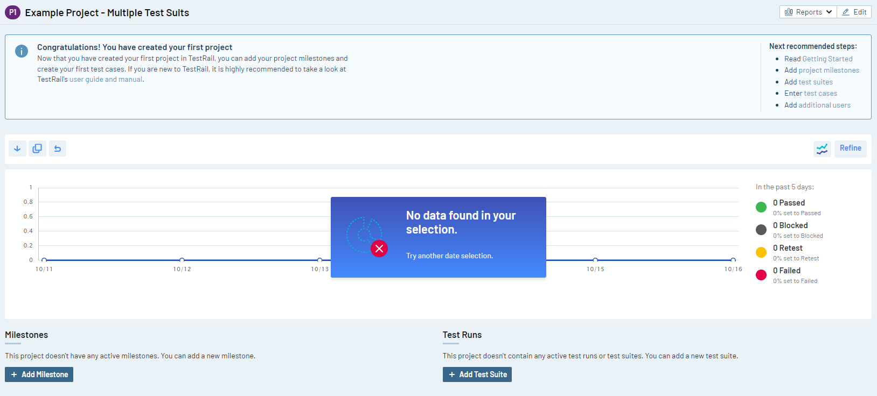

**3.3.** Click the **+ Add Test Suite** link under your new project.

Then choose a meaningful name for your test suite and maybe you would like to also write a description.

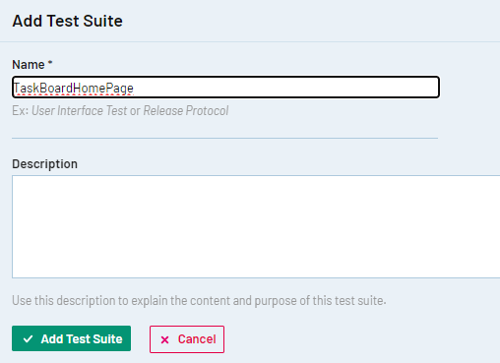

And your first test suit is ready.

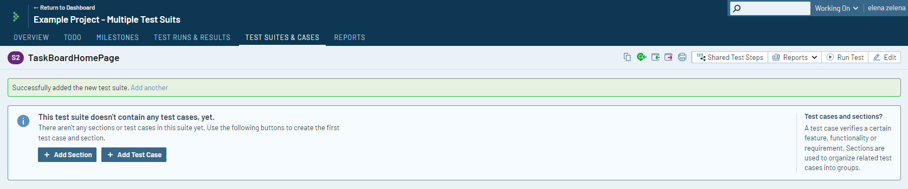

**4. Adding Test Cases**

**4.1.** Now let's add your first test case. Click **+ Add Test Case** button.

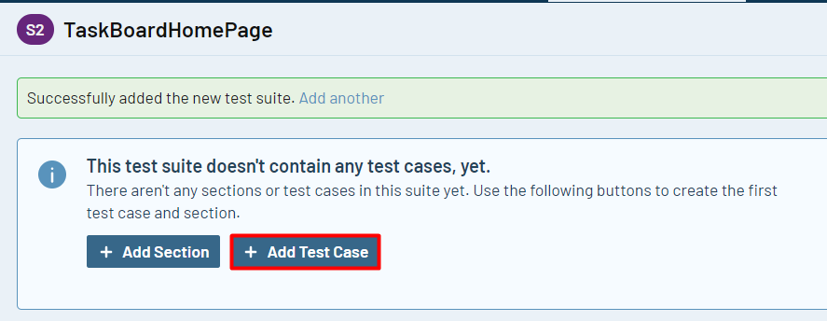

**4.2.**A detailed Test Case view appears, as shown below. Let's add a simple test named "Search"

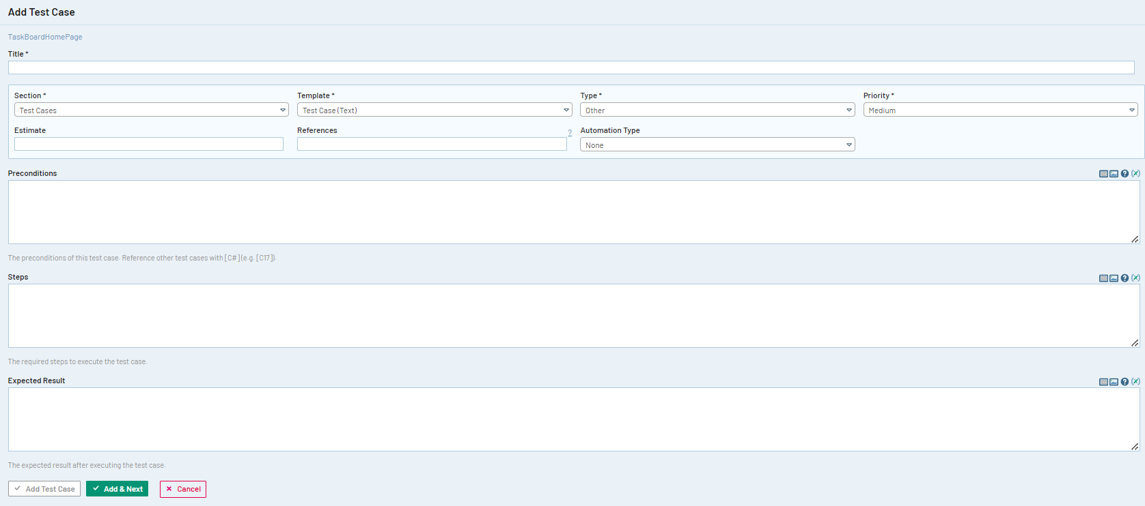

**4.3.** The following four fields are required and can be used to sort and filter test cases: Section, Template, Type, and Priority. The optional "Automation Type" field is for integration with a test automation tool.

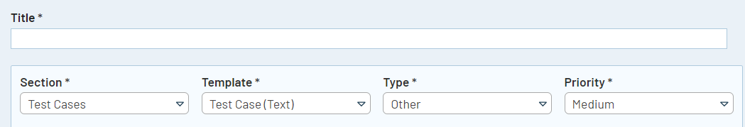

* 1. **Section** defaults to Test Cases. A section is created automatically for each new project.
  2. **Template** defaults to Test Case (Text). TestRail comes with three built-in test case templates:
     + **Behavior Driven Development**: You can create and run Behavior-Driven Development (BDD) scenarios using Gherkin syntax.
     + **Exploratory Session:** Includes text areas for the mission and goals of the exploratory session.
     + **Test Case (Steps):** Includes a text area for pre-conditions, plus rows for individual test steps with the expected result for each step. You can add a screenshot to each individual step.
     + **Test Case (Text):** Includes text areas for pre-conditions, test steps, and the expected result (shown above). You can add screenshots to these text areas.
  3. Choose a **Type** for the test, such as Regression, Functional, Performance, Automated, etc.
  4. Set a **Priority**, such as Critical, High, Medium, or Low.

**4.4.** Now you can complete the test case with pre-conditions, steps, and the expected results. Once you’re done defining the test, click on **Add Test Case**. The test case summary appears, as shown below:

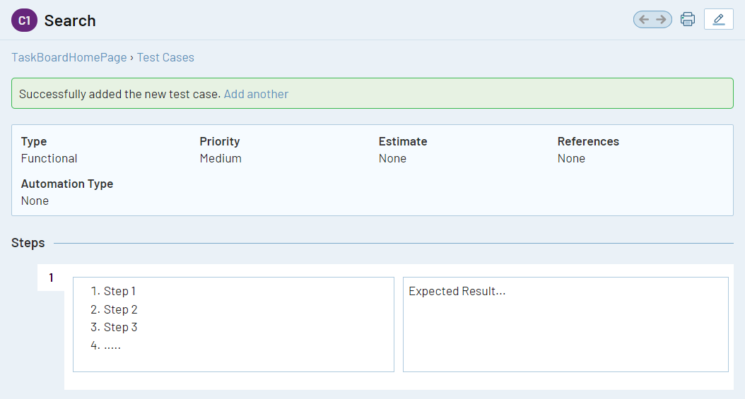

**4.5. Let's add a few more test cases.**

Click the **Test Cases** link to display the test case menu as shown below. All we really need right now is the title for each test case, so let's do this quickly using the Test Case Menu. Just click the **Add Case** link at the bottom of the list of test cases to add a title.

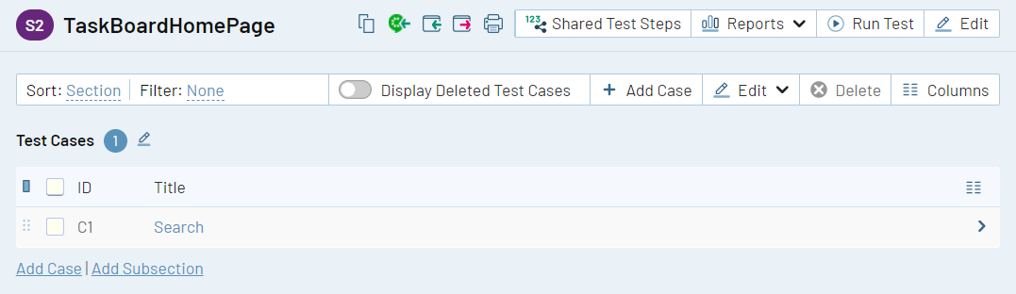

**5. Build a Test Run**

**5.1.** After creating your test cases, the next step is to build a test run. This is a set of tests that you want to use for a specific purpose such as regression testing, smoke testing, new features testing, risk-based testing, acceptance or in-sprint testing.

For each test run, you can create a name & description, link to a milestone, identify which test cases to include, and assign the run to a particular user or group for execution. Click the **Test Runs** Link, and then click the **Add Test Run** button.

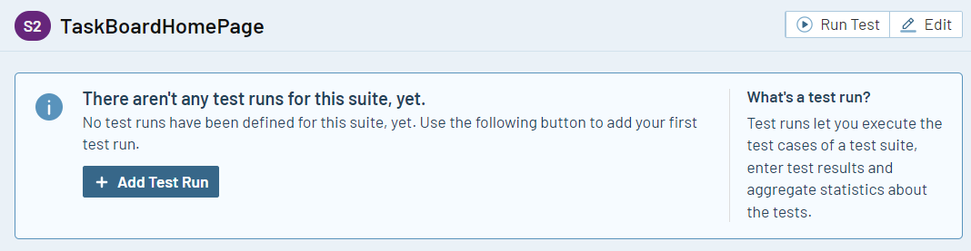

**5.2.** The **Add Test Run** screen appears, as shown below. As we chose the multiple test suites option earlier, the name defaults to the name of the test suite. You also have the option of assigning the test run to a **Milestone**.

Use the **Assign To** field to assign the test run to a user. Let’s go ahead and choose the option to **Include all test cases**, and then click on **Add Test Run**.

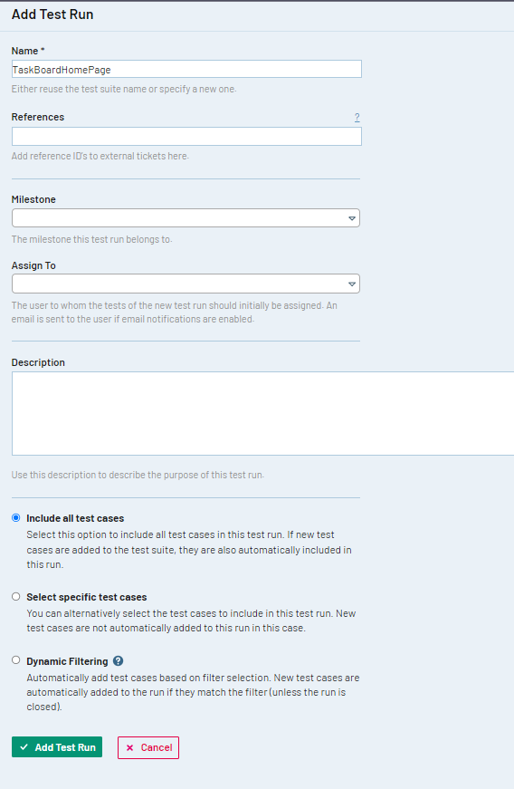

**5.3.** Now the **Test Runs & Results** screen appears. If you are following along with this walkthrough, you will see a single test run, that is zero percent (0%) complete.

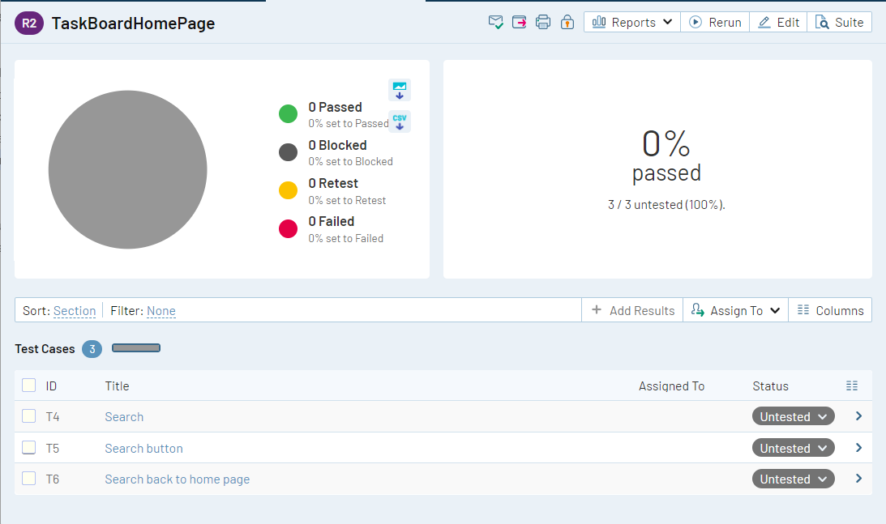

**5.4.** The screenshot below shows the status of a test run in progress.

As each test is executed, a tester can update its status as passed, failed, etc. It's also possible to set the status of multiple tests at once. If you're following along with the walkthrough, use the drop-down to set the status of your **Search** test case to **Passed**.

[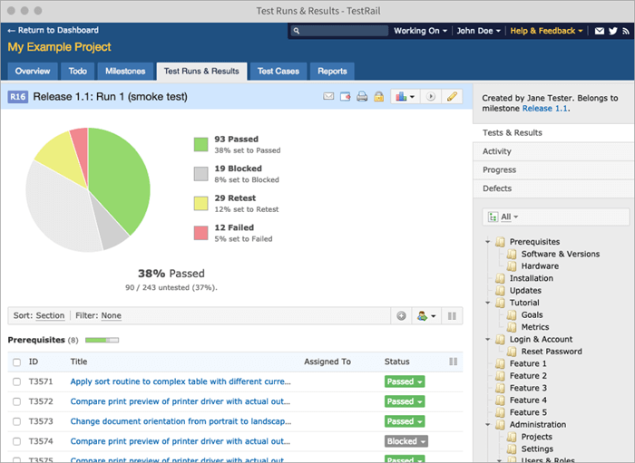](https://www.softwaretestinghelp.com/wp-content/qa/uploads/2019/03/15_Testrun_Details.png)

**6. Results**

**6.1.**  The **Add Result** window will appear, where you can add comments about the test, assign it to another team member, attach a screenshot, and even push the defect to your integrated issue tracker.

**For Example**, assume that you’re using Jira for issue tracking. After you submit your result, the test case is updated with the defect ID in Jira, and the Jira issue remains connected to the test case through the TestRail API. Any updates to the issue in Jira will also update TestRail.

After the defect is fixed, you can use TestRail’s re-run feature to re-execute the test and enter the new results.

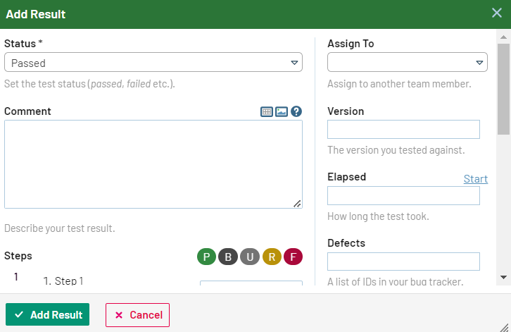

**6.2.** Click **Add Result** to close the window and return to the test run in progress. Notice that the pie chart has been updated to reflect the status change.

**7. Reports**

**6.3.** As you’ve got a test result, you can explore many customizable reports within TestRail. The sample screen below shows the reports available from the test run. More reports are available from the **Reports** tab.

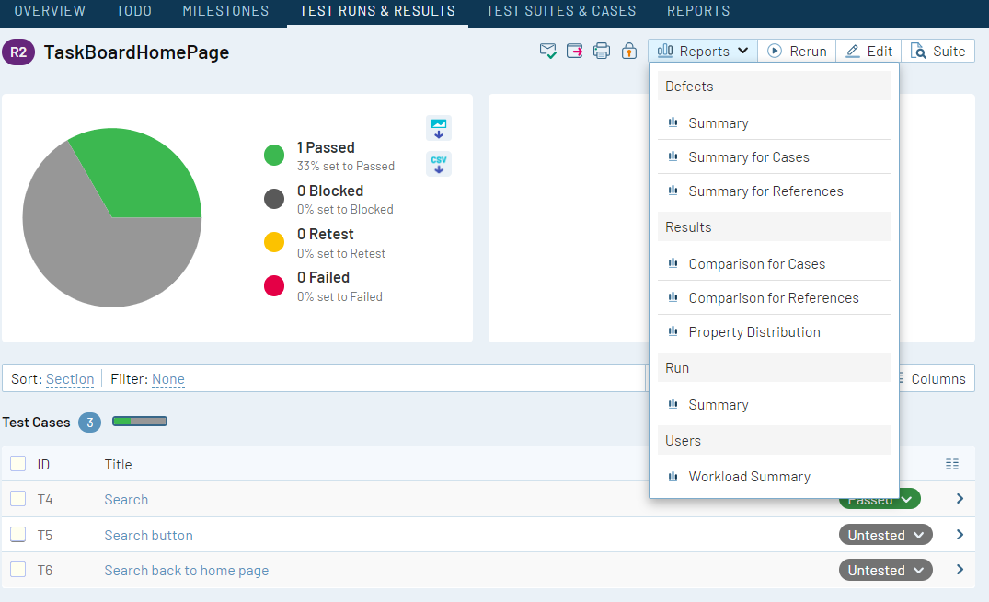

**8. Milestone Setup**

Although it isn't necessary to set up milestones to execute test runs, it's a good practice.

Milestones allow you to track progress across multiple test runs for goals such as a software release. Use the **Milestones** tab to add them.

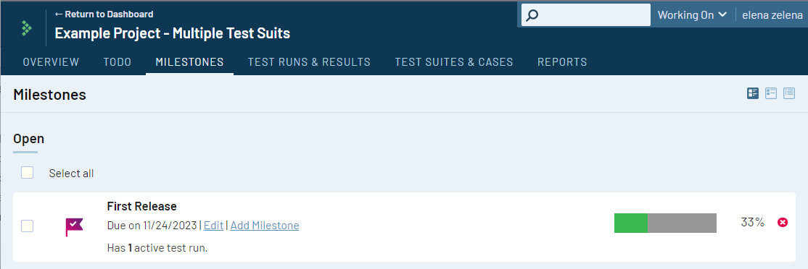

Once all tests are complete in a test run, you can lock the run which will prevent future changes. Hence, even if a test case changes for a future run, its definition is preserved for the current run, in case you need to audit the results later.

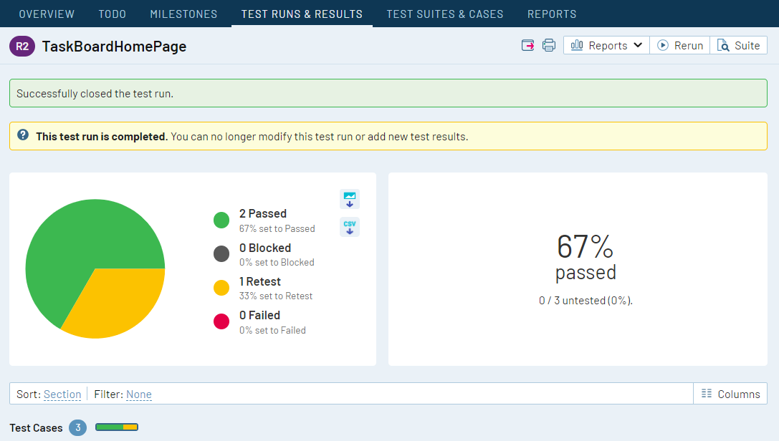

**9. Additional Videos**

If you are interested and curious about TestRail, we recommend watching the [Official TestRail Training Video Course](https://www.testrail.com/videos/introduction-projects/)

**10. Connect TestRail and Jira**

**9.1. Generate a Jira Cloud API Token**

1. Login to your Jira Cloud instance and go to account settings. This can be accessed by clicking your circle icon on the top right-hand side and selecting **Manage Account.**
2. Select the **Security** menu and click on the [**Create and manage API tokens**](https://id.atlassian.com/manage-profile/security/api-tokens) link.
3. Click **Create API token** and provide a label name. This can be anything you prefer.
4. Be sure to copy or save your token as you will need this later on. Afterwards, proceed with selecting **Close**.

**DEMO: CREATE API TOKEN -** [**https://www.youtube.com/watch?v=rJvNDh82SlM**](https://www.youtube.com/watch?v=rJvNDh82SlM)

**9.2. Configure Jira integration in TestRail**

1. Log in to your TestRail instance and navigate to **Administration > Integration**.
2. Select the **Configure Jira Integration** button.
3. Provide your Jira Cloud Web Address URL. Usually, it looks something like *https://yourcustomname.atlassian.net*.
4. Under **Jira Version**, it should remain Jira Cloud as the option.
5. Under **Jira Email address**, provide the email address you have with your Jira Cloud instance.
6. Ensure that both the **Defect** and **Reference** checkboxes are enabled and select **Save Settings.**
7. Scroll down and select **Save Settings** to finalize the changes.

For Jira cloud integration, you should use the **Jira Cloud plugin**, and authenticate the integration using your **Jira email address** and **Jira API token**.

**DEMO: CONFIGURE JIRA -** [**https://youtu.be/VDzn6PLyqSk**](https://youtu.be/VDzn6PLyqSk)

**9.3. Get the "TestRail Integration for Jira" app**

The "TestRail Integration for Jira" app allows you to directly review related test results, test case links, TestRail dashboard statistics and new case buttons directly from inside Jira. To get started, simply activate the TestRail add-on for Jira Cloud from the Atlassian Marketplace:

[**Activate TestRail add-on from Atlassian Marketplace**](https://marketplace.atlassian.com/plugins/com.testrail.jira.testrail-plugin)

Alternatively, you or your Jira administrator can enable the add-on within your Jira instance by navigating to**Personal Settings > Apps > Explore More Apps**, then search for TestRail. From there, click the **TestRail app  >**  **Get App > Get It Now**.

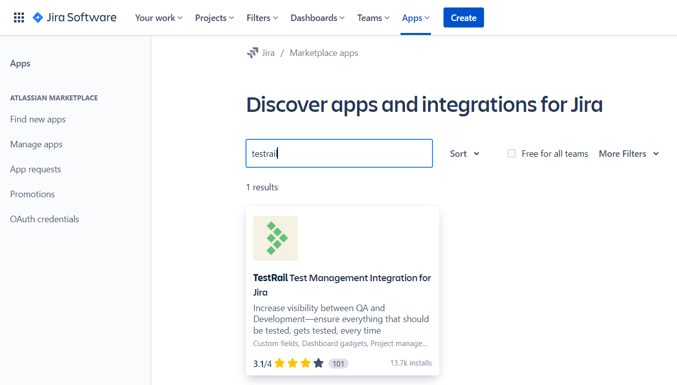

Next, simply configure the add-on with your TestRail address and key.

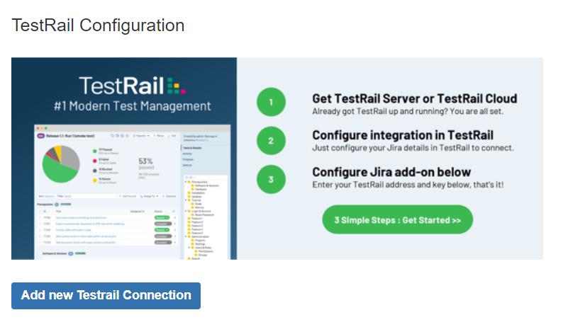

Then simply configure your TestRail address and integration key and any additional optional settings.

